LiPo Battery

E&J 674361P

3.7V 2000mAh 7.4Wh

2019/03/20

Capacity 2000mAh

Nominal Voltage 3.7V

Voltage at end of Discharge 3.0V

Charging Voltage 4.2 +-0.03V

Standard Charge: Current 0.2C 6 hours

Standard Discharge: 0.2C

Fast Charge: 1C

Fast Discharge: 1C

Standard Charge/Discharge Rate: 2000mAh x 0.2C = 400mAh

Fast Charge/Discharge Rate: 2000mAh x 1C = 2000mAh

Math tricks to calculate percentage of the battery

4.2V - 100% multiply By 100 = 420 (remove decimal part)

3.2V – 0% x100 = 320

Issue VoltDivider not enabling

According schematic pin 21 is responsible to enable MOSFET

Error PIN13 is not connect to volt-divider but 37. ( Modification was not upload on diagram)

Searching in the heltec.cpp function VetexOn() enable external voltage missing declaration to set pin 21 as output

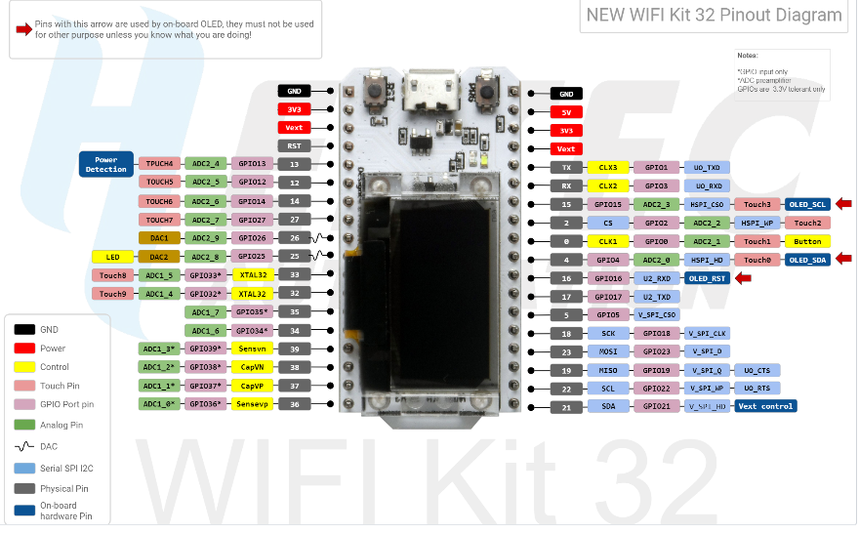

Define Vtex to 21

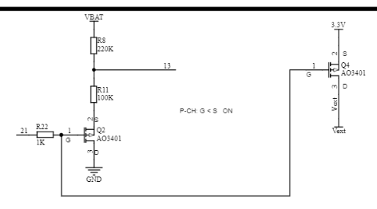

Figure - Volt divider Heltec-ESP32 Schematic Diagram

And call function VextON() on the application



ESP32 A/D converter

12bit

Full scale 3.3V

Range 4095 to 0

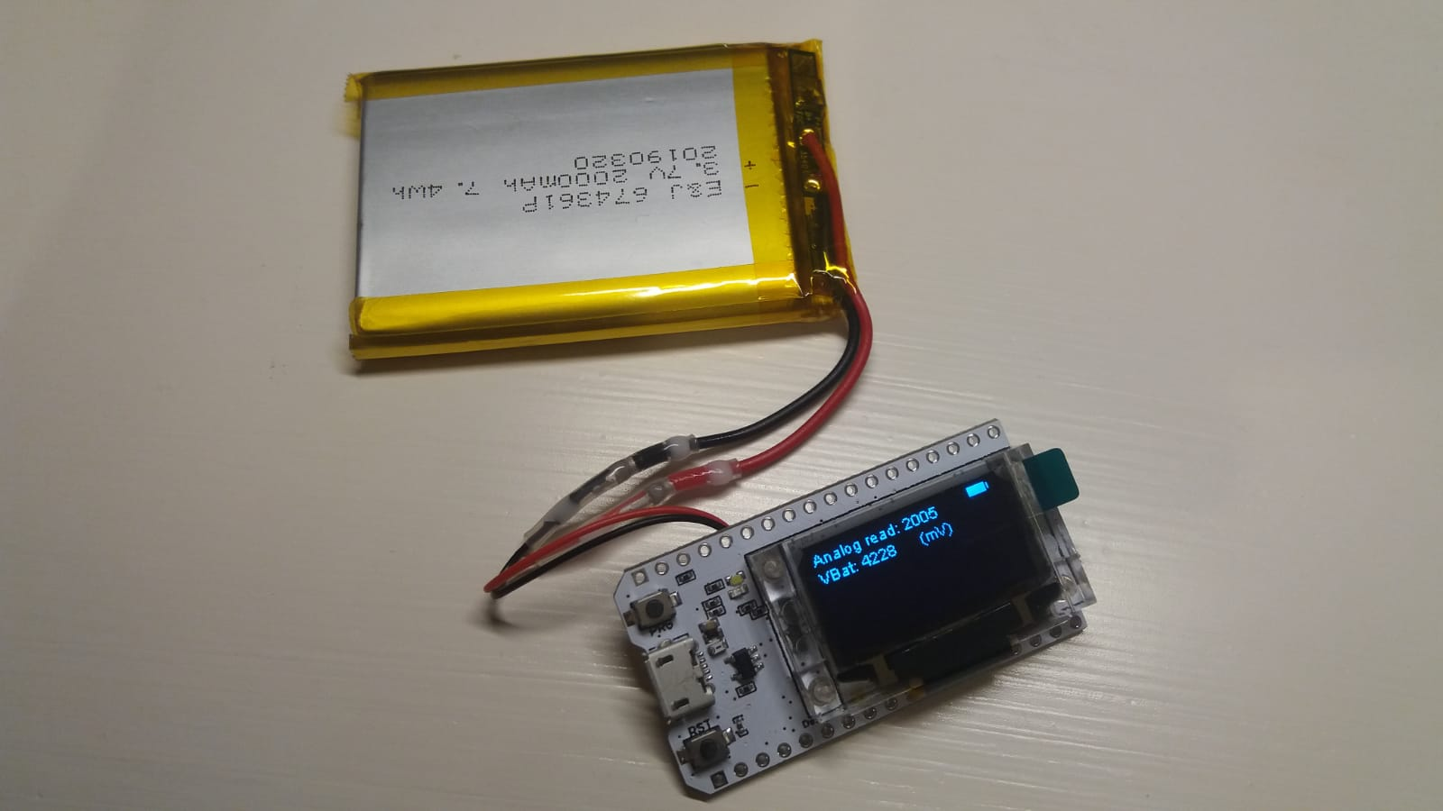

<https://github.com/Heltec-Aaron-Lee/WiFi_Kit_series/blob/master/SchematicDiagram/New_WIFI_Kit_32_Schematic_diagram.pdf>

<https://github.com/Heltec-Aaron-Lee/WiFi_Kit_series/issues/90>

<http://community.heltec.cn/t/heltec-esp32-wifi-kit-example-to-read-a-voltage/115>

<https://randomnerdtutorials.com/esp32-adc-analog-read-arduino-ide/>